Strand Filtering Woven Wire cloth
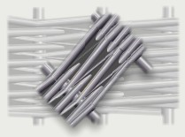 | Strand Filtering Woven Wire Cloth consists of wire strands in warp and weft.  Warp strand consists of five wires, weft strand consists of seven wires. Twilled weave. Width of cloth-1000mm. Material-monel НМЖМЦ-28-2,5-1,5.  Used for filtering of oil products.

Gauze № | Number of strands per 1 inch |  | Wire diameter in strand, mm |  | Wire diameter in strand, inch |  | Number of strands |  | Weight in kgs per 1 sq.m.
Gauze № | warp | weft | warp | weft | warp | weft | warp | weft | Weight in kgs per 1 sq.m.
140/140 | 35,6 | 35,6 | 0,18 | 0,12 | 0,007 | 0,005 | 5 | 8 | 2,8

